Generally the idea of Authentication is to require that clients provide some sort of unique information, with the goal of proving the request is coming from a user or application that actually exists, and is allowed to make that request. The unique information is usually referred to as “credentials” and these will be given to you by developers on the team in charge of the API. If the API belongs to another company you can often sign up for “API Access” or “API Keys” on their website somewhere.
Authentication primarily allows APIs to restrict access to various endpoints, but it also offers APIs the chance to track users, give endpoints user context (GET /feed should only return the _current users_ feed), filter data, or even throttle and deactivate accounts that overdo it.
Some are completely public with no keys at all. Completely open APIs with no keys seem to be getting rarer over time, as APIs get more important, do far more, and are increasingly dynamic.
To get the specifics for a particular API, their documentation is a fantastic place to start. Usually API documentation will contain an “Authentication” section in their docs, and this will usually be towards the start.
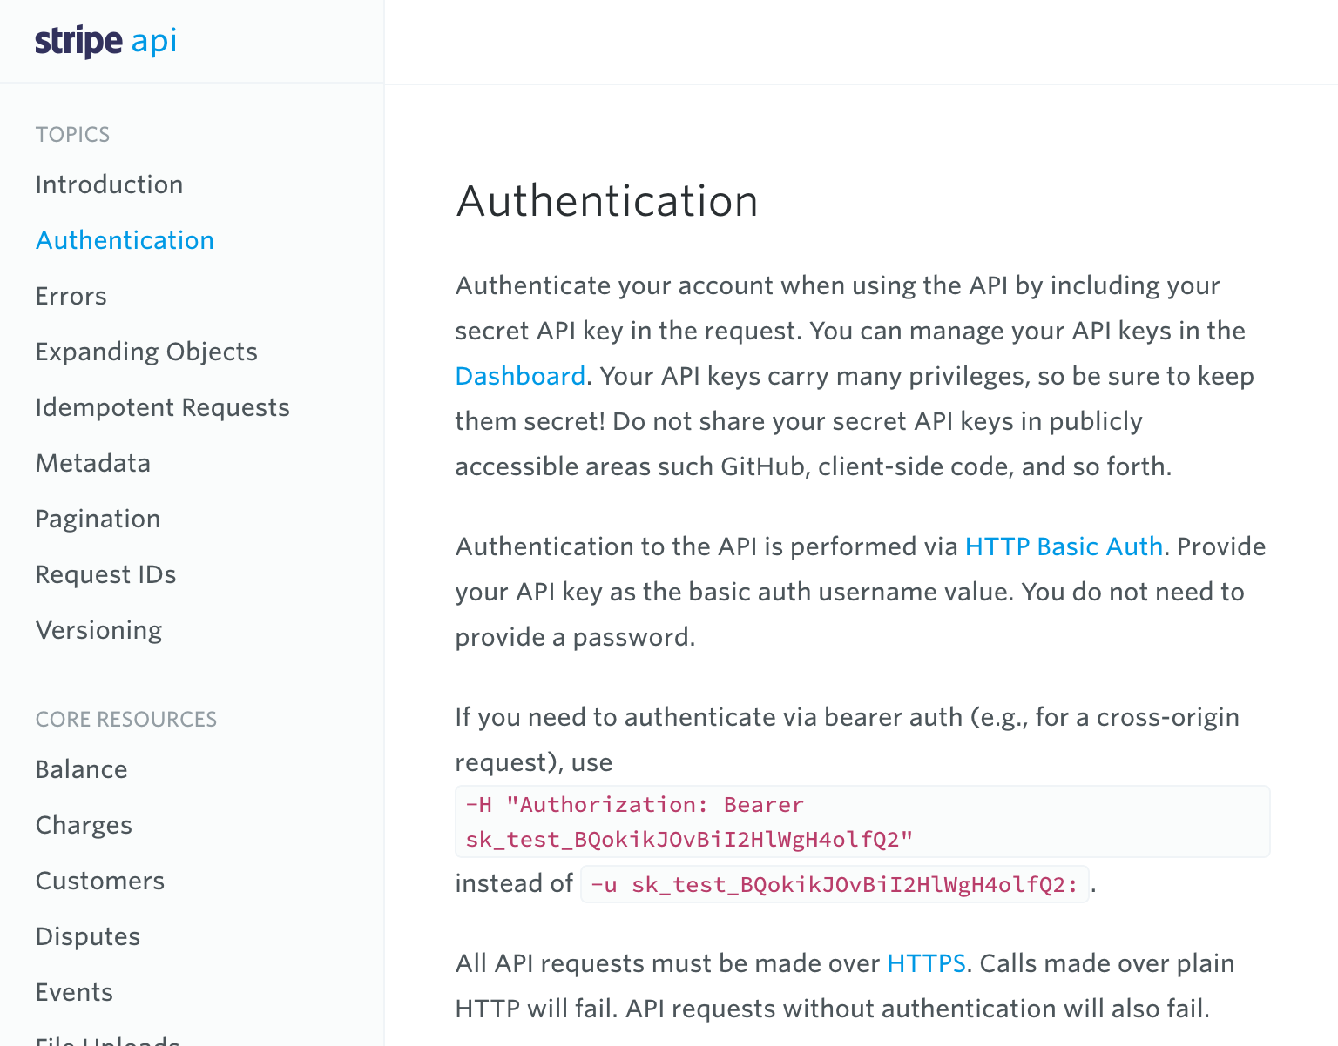
Screenshot from Stripe: Authentication
Here Stripe are making it quite clear where you can find your API keys, and talk about two approaches to sending them.
What confuses many folks when faced with HTTP Authentication, is that most of the time the authentication happens on every single HTTP request.
That is right: Every. Single. Request.
This sounds bizarre at first, as we are so often used to the concept of “Users logs in, then they have a session and can do logged in stuff until they log out or the session expires” being the one paradigm for how users login. That paradigm certainly exists for some APIs, but its rare, and for plenty of good reasons.
To cut a long story short, servers are happier when they do not need to remember who a specific user is. For example, if the API actually has multiple application servers all running behind load balancers, a client could hit a different server with each request they make. If cookies were used, then the user would be logged out every time the load balancer routed them to a different application server, unless it went to the trouble of maintaining “sticky sessions” to keep the user hitting the same server. That is all well and good until that application server is replaced by another instance on deployment… should users really be logged out due to a deployment?
For this, and many other reasons (like not having to worry about logouts), HTTP Authentication tokens are passed on every single request made.
Stripe have already mentioned HTTP Basic Auth and Bearer, which are two very similar approaches to authentication in HTTP. There are quite a damn lot of authentication strategies you could bump into, and whilst you do not need to know them all, you will probably want to read the appropriate section when an API you are looking at uses it:
- HTTP Basic
- HTTP Digest Auth
- Bearer
- OAuth 1.0a
- OAuth 2.0
- JWTs
TODO Explain how to work with them all. Ugh it’s gonna take a while.

